Warning - Trailer Sway Reduce Speed – CGEA1.3

Functional Description

The purpose of the Trailer Sway Reduce Speed Warning is to inform the driver that the Advancetrac (IVD or RSC) telltale event indication is actually due to a trailer sway event.

The Trailer Sway Reduce Speed Warning correlates the TRLR_SWAY_EVNT_IN_PROGRESS signal and the Operational _Mode to determine when to display the Trailer Sway Reduce Speed Warning.

Interfaces

Interface Context Diagram (I/O Block Diagram)

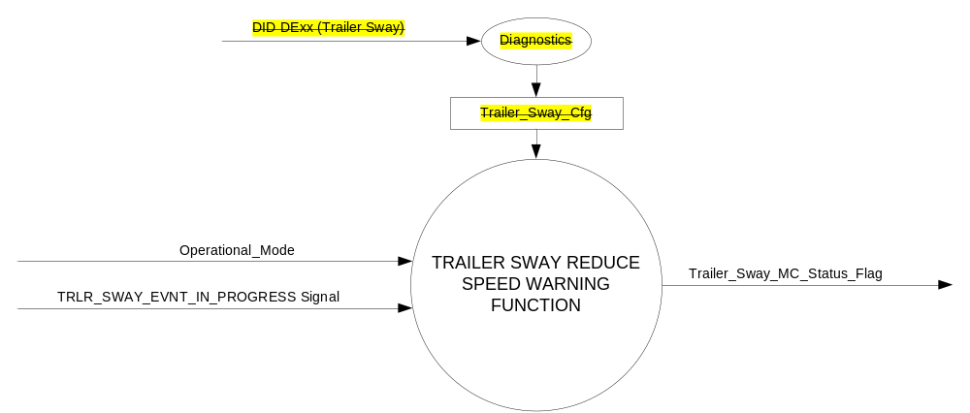

Figure 1 Trailer Sway Reduce Speed Warning Context Diagram

Inputs
      - INTERNAL:
    - Operational_Mode
    - Trailer_Sway_Cfg
- MUX message on the CAN Bus from the ABS

- TRLR_SWAY_EVNT_IN_PROGRESS Signal
Signal Name | Size (bits) | Detail | Units | Res. | Offset | State Encoded | Min | Max
TRLR_SWAY_EVNT_IN_PROGRESS | 1 |  | SED | 1 | 0 |  | 0 (0x0) | 1 (0x1)
 |  | No |  |  |  | 0x0
 |  | Yes |  |  |  | 0x1

Output
Trailer_Sway_MC_Status_Flag

Function/Performance

Operational Modes

Mode | Differentiating Vehicle Conditions
Sleep Mode | Trailer_Sway_MC_Status_Flag = Inactive
Limited Mode | Trailer_Sway_MC_Status_Flag = Inactive
Normal Mode | Trailer_Sway_MC_Status_Flag = Inactive/Active
Crank Mode | Trailer_Sway_MC_Status_Flag = Inactive/Active

The above table references the setting of the Warning flag as per this section. However, the actual warning display operational modes are displayed in the Message Center section of this SPSS.

Voltage Levels

Refer to the Cluster Features Table located in the Operational Modes and Voltage Range Strategies Section of this SPSS.

Human-Machine Interface

Visual

Indicator Graphics / Display Format
Message Center Text Warning Message as defined in section 1.3.5.7 of this document.

1.3.3.1.2 Indicator Color Coordinates

Reference section COLOR & ILLUMINATION REQUIREMENTS (GRAPHICS).

Audio

None

Switch Control Logic

None.

System Accuracy

Within 100 msec of receiving a message that results in a change of state the cluster will update the output flag to the proper state.

Operation: Performance and Functional

Subsystem Algorithm Flowchart / State Diagram
Note Trailer_Sway_Cfg is still used for Trailer Sway Control Function

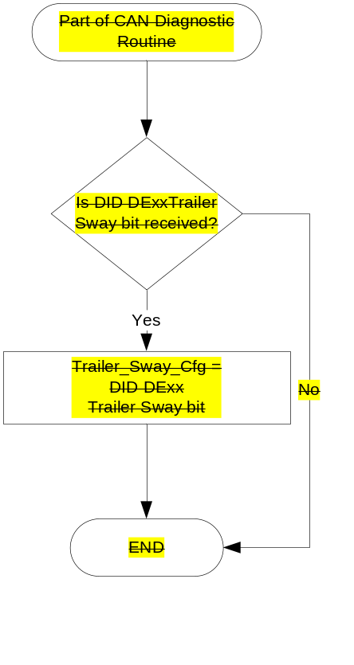

- State Matrix for Trailer Sway Reduce Speed Warning
Operational_Mode | Trailer_Sway_Cfg | TRLR_SWAY_EVNT_IN_PROGRESS  Signal | Trailer_Sway_MC_Status_Flag
Normal or Crank | Enabled (0x1) | Yes (0x1) | Active
Normal | Enabled (0x1) | Missing as per 1.4.1 | Inactive
All Other Cases |  |  | Inactive

- Trailer Sway Reduce Speed MC Status Flag to MC Warning Message ID
Trailer_Sway_MC_Status_Flag | MC Warning Message ID
Inactive | None
Active | W502 (Trailer Sway Reduce Speed)

Operation Description (supports algorithm flowchart /state diagram)

- When Trailer_Sway_MC_Status_Flag = ACTIVE, Warning ID W502 will be ACTIVE.
- For definition of how the Message Center arbitrates and displays Active warnings, see the Warning / Alert Display Logic Diagram, located in the Message Center – X Display with W Button Interface section of this SPSS (where X and W are appropriate values in this document).

Function Safety Classification (EMC)

Class B

Memory Storage
Parameter Name | Description | Value at  Battery Connect | Value at  Module Wake-up
Trailer_Sway_Cfg | Configures cluster to allow Trailer Sway feature (set to enable at cluster end of line) | Do Not Init | Do Not Init
TRLR_SWAY_EVNT_IN_PROGRESS Signal | CAN Signal sent from the ABS | No (0x0) | No (0x0)
Trailer_Sway_MC_Status_Flag | State variable used by M/C Warning Arbitrator | Inactive | Inactive
Operational_Mode | 4 state indicator for cluster operational mode | Limited | Limited or Normal or Crank

Prove Out

No.

Reconfigurable Telltale

No.

Message Center Msg

Message ID W502 as defined in the Text Message List section of this SPSS.

Error Handling

Missing Message Strategy

The signals will be declared missing as per the Diagnostics section of this SPSS.

DTCs states and history will be determined as per the Diagnostics section of this SPSS.

If Trailer_Sway_Cfg = Disabled, the cluster shall never log a missing message DTC due to this feature.

No Missing Message DTCs are logged for this warning.

Diagnostics

Self Test

None

Engineering Test Mode

Not Applicable

Part II Performance

Supported Diagnostic Trouble Codes (DTCs)
None

DTC | Description
C12100 | Lost communication with anti-lock brake system (ABS) control module

DID DExx
Block  Num | Block Description | Byte(s) | Bits | State: Description | "0" | "1" | Default | Comments/Information
PACKETED BLOCKS
$xx | Option Content (B&A) | * | * | Trailer Sway | Disabled | Enabled | Enabled | Disabled means the feature is not present in the vehicle
 | *Byte and bit location to be identified in Part II Specification for this cluster

Reference Specification

IS-0001 WARNINGS/INDICATORS/DISPLAYS PROVEOUT
IS-0052 OPERATING VOLTAGES - FUNCTIONAL/PERFORMANCE
IS-0069 FUNCTIONAL IMPORTANCE CLASS
IS-0324 WINDSHIELD & OTHER REFLECTIONS
IS-0327 WARNING INDICATOR EVALUATION
IS-0379 NORTH AMERICAN WARNINGS AND INDICATORS STRATEGY

IL-0017 TELLTALE AND INTERIOR ILLUMINATION – COLOR AND INTENSITY
IL-0019 GENERAL ILLUMINATION DIMMING
IL-0021 CRAFTSMANSHIP – DISPLAYS
IL-0022 GENERAL ILLUMINTATION COLOR
IL-0023 CLARITY/LEGIBILITY/READABILITY/VISUAL CONTRAST
IL -0043 OPERATIONAL ENVIRONMENT FUNCTIONALITY
IL -0045 COLOR
IL -0047 TELLTALE, INDICATOR AND DISPLAY LIGHT INTENSITY
IL -0048 ILLUMINATION ACCEPTABILITY

03-0661 PLACEMENT: CONTROL AND DISPLAY LOCATIONS
03-0662 PLACEMENT: LOGICAL GROUPING FUNCTION AND USAGE
03-0664 PLACEMENT: DOWN VISION TO COMPONENTS WITH HIGH VISUAL DEMAND
03-0665 PLACEMENT: EXPECTED LOCATIONS OF CONTROLS AND DISPLAYS VDS
03-0670 INTERIOR VISIBILITY
03-0671 INTERIOR VISIBILITY: REFLECTIONS FROM COMPONENTS & SURFACES
03-0672 INTERIOR VISIBILITY: REFLECTIONS IN DISPLAYS
03-0673 INTERIOR VISIBILITY: VISUAL OBSCURATIONS
03-0674 INTERIOR VISIBILITY: ILLUMINATION CONTROLS / DISPLAYS
03-0675 INTERIOR VISIBILITY: VEILING GLARE
03-0677 INTERIOR VISIBILITY: SUNLIGHT WASHOUT
03-0681 IDENTIFICATION: CHARACTER AND SYMBOL SIZE
03-0682 IDENTIFICATION: LEGIBILITY
03-0685 IDENTIFICATION: SYMBOLS, ABBREV FOR CONTROL
03-0721 LOGIC OF OPERATION: OPERATIONAL STEREOTYPES
03-0722 LOGIC OF OPERATION: INTERPRETATION
03-0723 LOGIC OF OPERATION: USE OF SYSTEMS WITH VISUAL DISPLAYS

Revision History

SPSS Module Revision History

Revision Level | Name | Change Description | Date
1.0 | V. Patel | Updated for CGEA 1.3 based on CGEA STSS v1.1  Section 1.2.2 – Removed table referencing the HS-CAN message that contains the input signals.  Section 1.4 – Rewritten. Deleted references of specific missing message flags and timer.  Section 1.5.3 – Deleted DTC logging criteria from the table. Moved DTC table above the DE00 block. | 4/14/2010
1.1 | S. Watkins  M. Hakim | Update to change DE00 to DExx and remove System Check Function:  Changed DE00 to DExx throughout the document.  Section 1.3.5.1: Removed table for “System Check Function”.  Updated document footer. | 9/17/2013
2.0 | J. Blatchford | This update removes the configuration to allow the warning to be displayed when the Trailer Sway Control Function settings screen is configured off but the trailer sway feature is implemented on the vehicle. EU applications implement Trailer Sway Control feature without the customer option to turn it off via the settings menu. TRLR_SWAY_EVNT_IN_PROGRESS signal is frame gateway in BrakeSysFeatures_2_HS1 message and is always there so there is no need to use a EOL configuration for this warning. this update was approved offline as documented in 9/28/2017 DI Change Control Minutes. Changes highlighted in yellow.  - 1.2.1: Removed configuration from diagram.  - 1.2.2: Removed Trailer_Sway_Cfg  - 1.3.5.1: Removed configuration flow chart, added note.  - Table 1.1: Removed column.  - 1.5.3: Removed  - 1.3.5.4: Removed DTC table and DID DExx table. Added word none. | 9/28/2017

